**Activity 1:**

1. 3 pools for memory are static, heap and stack. Static stores global variables, stack stores local variables and heap is dynamic storage.
2. 1. 3 variables are declared.
   2. Two of them are pointers. Ptr is a pointer variable that holds address of an int. Handle is a double pointer which holds the address of a pointer.
   3. Ptr and handle pointer are stored in Heap while num is stored in stack.
   4. Ptr will points to Heap

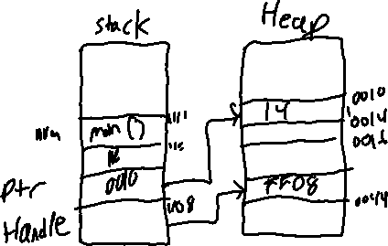

**Exercise Structures in C:**

1. Structures are stored in the order that they are declared.

**Assignment 1 Arrays and pointers**

1a) We need to pass the size of array to the function to be able to go through the elements up to the last element of the array. If the size is not known then the user wont be able to go through the last element of the array or the user might go beyond the last element.

1b)The original array is changed at the end of this function because when the array is passed to a function not values but addresses are passes. Since they’re passed the changes reflect.

1c) If new array is not used the original array will be no more available after sorting due the fact above mentioned.

A new array(s_array) is needed to store the result of the sorted values because if a points to address of a[0] we use the operator *. If the new array isn’t used then the original array will not be available after sorting.